LAB -1

* **FUNDAMENTALS OF OPERATING SYSTEM**

**Operating System** lies in the category of system software. It basically manages all the resources of the computer. An operating system acts as an interface between the software and different parts of the computer or the computer hardware. The operating system is designed in such a way that it can manage the overall resources and operations of the computer.

Operating System is a fully integrated set of specialized programs that handle all the operations of the computer. It controls and monitors the execution of all other programs that reside in the computer, which also includes application programs and other system software of the computer.

An Operating System (OS) is a collection of software that manages computer hardware resources and provides common services for computer programs. The operating system is the most important type of system software in a computer system.

* **Types of Operating System are-**

**Windows**- The [Windows](https://en.wikipedia.org/wiki/Microsoft_Windows) operating system from Microsoft is a graphical operating system. Users can use it to read and store files, run apps, play games, and watch videos, as well as connect to the internet. It was made available for both personal and professional use.

**DOS-** A disk operating system (DOS) is an operating system for x86 based personal computers mostly developed by Microsoft. DOS was the main operating system for IBM PC compatible personal computers during the 1980s. It was gradually superseded by operating systems offering a graphical user interface (GUI) in various graphical Microsoft Windows operating system generations. DOS is also used to describe several similar command-line disk operating systems.

* **ABOUT UNIX**

UNIX is a powerful Operating System initially developed by Ken Thompson, Dennis Ritchie at AT&T Bell laboratories in 1970. It is prevalent among scientific, engineering, and academic institutions due to its most appreciative features like multitasking, flexibility, and many more. In UNIX, the file system is a hierarchical structure of files and directories where users can store and retrieve information using the files. UNIX is a family of multitasking, multiuser computer operating systems developed in the mid 1960s at Bell Labs. It was originally developed for mini computers and has since been ported to various hardware platforms. UNIX has a reputation for stability, security, and scalability, making it a popular choice for enterprise-level computing.

The basic design philosophy of UNIX is to provide simple, powerful tools that can be combined to perform complex tasks. It features a command-line interface that allows users to interact with the system through a series of commands, rather than through a graphical user interface (GUI).

* **FEATURES OF UNIX**
* **Multitasking**: A UNIX operating system is a multitasking operating system that allows you to initiate more than one task from the same terminal so that one task is performed as a foreground and the other task as a background process.
* **Multi-user**: UNIX operating system supports more than one user to access computer resources like main memory, hard disk, tape drives, etc. Multiple users can log on to the system from different terminals and run different jobs that share the resources of a command terminal. It deals with the principle of time-sharing. Time-sharing is done by a scheduler that divides the CPU time into several segments also called a time slice, and each segment is assigned to each user on a scheduled basis. This time slice is tiny. When this time is expired, it passes control to the following user on the system. Each user executes their set of instructions within their time slice.
* **Portability**: This feature makes the UNIX work on different machines and platforms with the easy transfer of code to any computer system. Since a significant portion of UNIX is written in C language, and only a tiny portion is coded in assembly language for specific hardware.
* **File Security and Protection**: Being a multi-user system, UNIX makes special consideration for file and system security. UNIX has different levels of security using assigning username and password to individual users ensuring the authentication, at the level providing file access permission viz. read, write and execute and lastly file encryption to change the file into an unreadable format.
* **Command Structure**: UNIX commands are easy to understand and simple to use. Example: "cp", mv etc. While working in the UNIX environment, the UNIX commands are case-sensitive and are entered in lower case.
* **Communication**: In UNIX, communication is an excellent feature that enables the user to communicate worldwide. It supports various communication facilities provided using the write command, mail command, talk command, etc.
* **Open Source**: UNIX operating system is open source it means it is freely available to all and is a community-based development project.
* **Accounting**: UNIX keeps an account of jobs created by the user. This feature enhances the system performance in terms of CPU monitoring and disk space checking. It allows you to keep an account of disk space used by each user, and the disk space can be limited by each other. You can assign every user a different disk quota. The root user can perform these accounting tasks using various commands such as quota, df, du, etc.

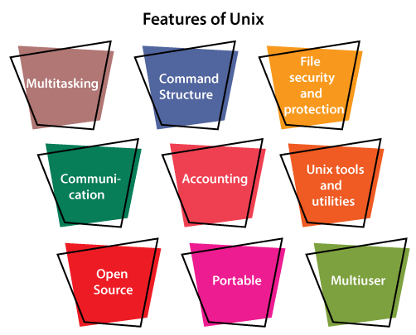

* **COMPARATIVE FEATURES WITH OTHER**

|  |  |  |
| --- | --- | --- |
| Features | UNIX Operating System | Windows Operating System |
| User-Interface | It comes with a Command Line Interface (CLI). | It comes with a Graphical User Interface (GUI). |
| Licensing | It is a free and open-source operating system. | It is a licensed operating system. |
| Security | It is more secure because all system updates require explicit user permission. | It is less secure than UNIX operating system. |
| Processing | It supports multiprocessing. | It doesn't support multiprocessing. |
| Case-Sensitive | It is fully case-sensitive, and files can be considered separate files. | It has case sensitivity as an option. |
| Basic | It is a command-based operating system. | It is a menu-based operating system. |
| Hardware | In a UNIX system, hardware support is limited. Some hardware could not have drivers built-in. | Almost all hardware has drivers available. |
| File System | It uses the Unix File System (UFS), which includes the STD.ERR and STD.IO file systems. | It makes use of the New Technology File System (NTFS) and the File Allocation System (FAT32). |
| Reliability | Unix and its distributions are well known for their high level of stability. | Although Windows has become more stable in recent years, it still falls short of the reliability offered by Unix systems. |
| Data Backup and Recovery | Creating a backup and recovery system in UNIX is time-consuming, but it is becoming easier with the release of new Unix distributions. | It contains a built-in backup and recovery system that makes it more user-friendly. |

* **DISTRIBUTION**
* **Kali Linux-**

Kali Linux (formerly known as BackTrack Linux) is an open-source, Debian-based Linux distribution aimed at advanced Penetration Testing and Security Auditing. It does this by providing common tools, configurations, and automations which allows the user to focus on the task that needs to be completed, not the surrounding activity.

Kali Linux contains industry specific modifications as well as several hundred tools targeted towards various Information Security tasks, such as Penetration Testing, Security Research, Computer Forensics, Reverse Engineering, Vulnerability Management and Red Team Testing.

Kali Linux is a multi-platform solution, accessible and freely available to information security professionals and hobbyists.



* **Red Hat** **Enterprise Linux**-

**Red Hat Enterprise Linux** is a distribution of the Linux operating system. The Red Hat organization develops it for the business or the enterprise market. It is also commonly abbreviated as **RHEL**.

The kernel of the RHEL is optimized to run with the hardware mostly present in large data centres. It has the capability to support software for automation, cloud computing, containers, middleware, storage, application development, microservices, virtualization, management, and more. This makes RHEL a very suitable operating system to be used in the business market.

The power of RHEL is not limited to large-scale data centres or business markets. Editions of RHEL are available for servers, mainframe, SAP applications, and desktop computers.

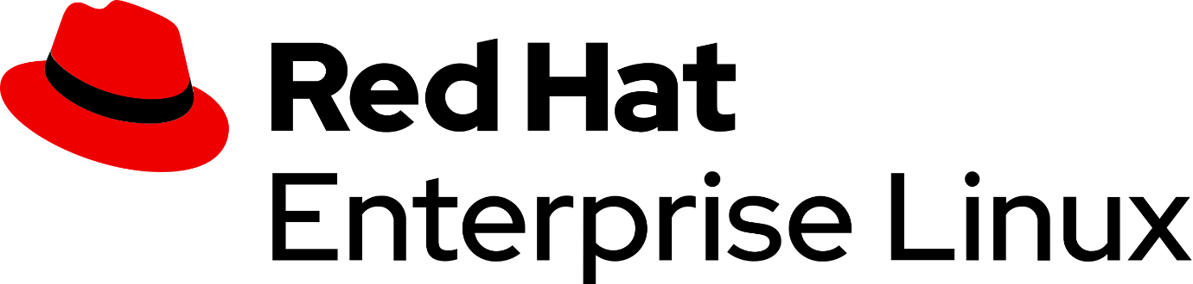

* **Ubuntu**

Ubuntu is a free and open-source distribution of Linux. It is an OS for cloud computing to support Open Stack. Ubuntu is integrated by the Canonical Community and it's freely available. Canonical Ltd. is also liable for the Ubuntu funding.

Ubuntu is published every 6 months. Also, free support is present for 9 months for every publication and LTS published every 2 years. The initial publication of Ubuntu was in 2004 October. Three Ubuntu editions are *Core Edition, Server Edition*, and *Desktop Edition*.

It is designed for network servers, smartphones, and computers. The system is integrated by a UK-based enterprise which is known as Canonical Ltd. Every principle used for developing the Ubuntu software is based on open-source software development principles.

